# Team Assignment: Part 1

### Purpose of a Website

**Reasons for a theme park operator to have a website:**

A good website promotes an image that the service is credible. Related to this, a website provides marketing around the brand of the theme park, conveying to the viewer whether the theme park appeals to their needs/wants. As part of a marketing strategy, a website differentiates the theme park from its competitors and builds brand recognition.

A website is a convenient way for a theme park to convey service information and for customers to obtain information without needing to use the phone or social media. As websites are the norm, a theme park without a website or with a poor, uninformative website may lose business if customers are not willing to pick up the phone or contact through social media. This also saves the business time and resources. A website is also useful in signposting contact information if customers have further questions.

A website can provide a visual guide to services offered, which is vital for both marketing and informational purposes. There are significant differences in the services offered by different theme parks. A visual guide to the rides available, the facilities and a map of the grounds will assist customers in understanding what the theme park offers.

**The people who might look at such a web site:**

* Potential customers: adults and children. For this reason, the website needs to be accessible for a younger audience as well.
* Confirmed customers who are using the website to plan their visit,
* Current visitors who need information about facilities and services whilst on site,
* Past visitors,
* Local residents, or the general public,
* Current and potential employees,
* Competitors,
* Investors.

**Reasons that they would be looking at the website:**

Anybody looking at the website could be a potential customer. They may be a member of the general public, looking out of curiosity because they have just become aware of the theme park and do not have any intention of visiting. They could be following an advertising link out of curiosity. Nevertheless, the brand marketing may compel them to consider visiting in the future and help to build brand recognition.

They may already have some intention to visit a theme park and therefore be a potential customer. Potential customers may be looking for information about the service to make a decision around whether it appeals to their needs. They may be planning a day out and be looking at the websites of several theme parks to compare the facilities available. The information and marketing images of the website will help to inform this decision.

Confirmed customers may be using the website to plan their visit. Current visitors may use the website to access resources that will be useful whilst on site, such as the park map. Past visitors may need contact information or follow up resources, for example park photographs or lost and found.

Current and potential employees may be interested in employment opportunities or HR resources.

Investors and competitors may be looking at the website to make judgements on the strength and credibility of the brand.

## Group Research on Theme Park Websites

**Disneyworld: https://www.disneyworld.eu**

Pros:

* Main video on landing page captivating,
* Well structured information with good balance of text and images,
* The homepage is nice and simple which makes it easy to navigate through

Cons:

* Text on scroll bar too small: problems in accessibility for visually impaired and children,
* On one occasion, internet struggled to load the video, highlights possible issue in some users loading this,
* Too much visual noise on landing page for my taste
* The nav bar seems out of place
* The drop down menu on the on the nav bar has to much information, which can make finding what you want a bit difficult

**Orlando: https://www.universalorlando.com/web/en/us**

Pros:

* Liked that the really practical info like opening hours, park map, and directions were highlighted on buttons at the top of the primary navigation bar,
* Easy to navigate, easy to find primary navigation bar,
* Compared to Disney, there’s still a lot of info on the home page but feels less busy. White space helps to make it feel less visually noisy,
* Secondary navigation bar under feature image easy to find, possibly contributes to website feeling less busy than Disney,

Cons:

* Aesthetically a bit boring, didn’t have the ‘wow’ factor.
* On some of the pages the text for the home button is too small, it can be easily missed.

**Peppa Pig World: https://peppapigworld.co.uk**

Pros:

* Homepage is very aesthetically pleasing, good use of bold, bright colours without being overbearing, good choice of feature image- bonus of being symmetrical,
* Simple layout makes it easy to navigate, navigation bar complemented by cartoon images, good accessibility for all,
* The look of this site was perfectly balanced, not too plain and not to flash either.

Cons:

* Not consistent in theme throughout, due to this being a smaller theme park within a theme park. Links redirect to general Paulton Park website, which is still easy to navigate but theme isn’t as aesthetically pleasing,
* Need to click through to Paulton’s Park website to find ‘help and information’ on the navigation bar in order to get practical info about opening times etc.
* The drop down menu on the Paulton’s Park website was too big and obtrusive.

**Playmobil Funpark:** [**https://www.playmobil-funpark.de/en/**](https://www.playmobil-funpark.de/en/)

Pros:

* Pirate animation when you open the home page is fun. Adds interest without being annoying or distracting. Only runs once which is good!
* Good use of colour to break up the homepage,
* Header simple with logo and navigation links, provides functionality without taking up too much visual space when scrolling,
* Visual icons on navigation bar, increased accessibility,
* Liked the attractions page (<https://www.playmobil-funpark.de/en/funpark-entdecken/attraktionen>), well structured and an ability to filter the attractions by age suitability,
* The Parkmap page was really nice, it clearly shows you where everything is and allows you to jump straight there

Cons:

* Really disliked the slider on the homepage, moved too fast for me and was just annoying. Would have been better with a static image,

**Legoland: https://www.legoland.com/new-york/**

Pros:

* Simple and well structured,
* Light load,
* No annoying pop-ups,
* Simple animations and hoover actions,
* Sticky footer with booking section,
* Varied page layouts without being too busy,
* Bright and captivating aesthetically,

Cons:

* No intriguing/captivating video,
* The site may be too simple,
* Layout isn’t for everyone,

**Six Flags: https://www.sixflags.com/overtexas**

Pros:

* Video on the home page makes you want to go there and try the rides
* Everything seems well placed and well structured

Cons:

* The promotional materials for limited time offers are easy to miss because they don’t stand out, instead they seem like the generic advertisements that you see on other sites.
* The nav bar wasn’t designed properly. The logo is being hidden by the video on the home page.
* The site looks flat, it doesn’t stand out at all.

## Content for Theme Park

Themes discussed:

* Sports,
* Cartoons,
* Children’s theme park. Could design our own character. Bear,
* Shapeland inspired by Sesame Street video: <https://m.youtube.com/watch?v=TdcHzquaMh8>

## Content:

‘Shapeland’

A family theme park aimed at children aged 0-5.

Promotes shape-recognition through friendly shape-themed characters and attractions. Delivers a fun and educational experience with a focus on providing family-friendly facilities.

Practical info:

* Park name,
* Park age suitability,
* Location,
* Ticket info,
* Opening hours,
* Contact details,

Attractions:

* Small, simple rides and attractions,
* Shape mascots in the park,
* Free balance bikes and scooters for toddlers to use in the park,
* Free trolley wagons,

Facilities:

* A range of food stands and restaurants, catering to all with healthy and sweet options,
* On-site first aid and emergency centre,
* Baby rooms with facilities for changing, bottle/food warming and breastfeeding,
* Quiet area for sleeping babies,
* Accommodation suggested but may require too much content for 3 page website,

## Possible Structure:

3 pages:

Page 1:

Homepage

* Park name and logo,
* Navigation bar with links to attractions and tickets pages,
* Feature image,
* Park age suitability,
* Location,
* Opening hours,
* Park map.
* Contact details,
* Image and short description of attractions and facilities with link to page 2,
* Feature button to link to tickets on page 3.

Page 2:

* Attractions and activities, buttons to filter by age?
* Description of facilities with image,
* Food and drink

Page 3:

* Promotional information about tickets, ticket prices, form to purchase tickets.
* Contact info.

## Wireframes, Drafting Stage:

Unable to do full nav bar as opposite

due to space constrictions of 3 pages.

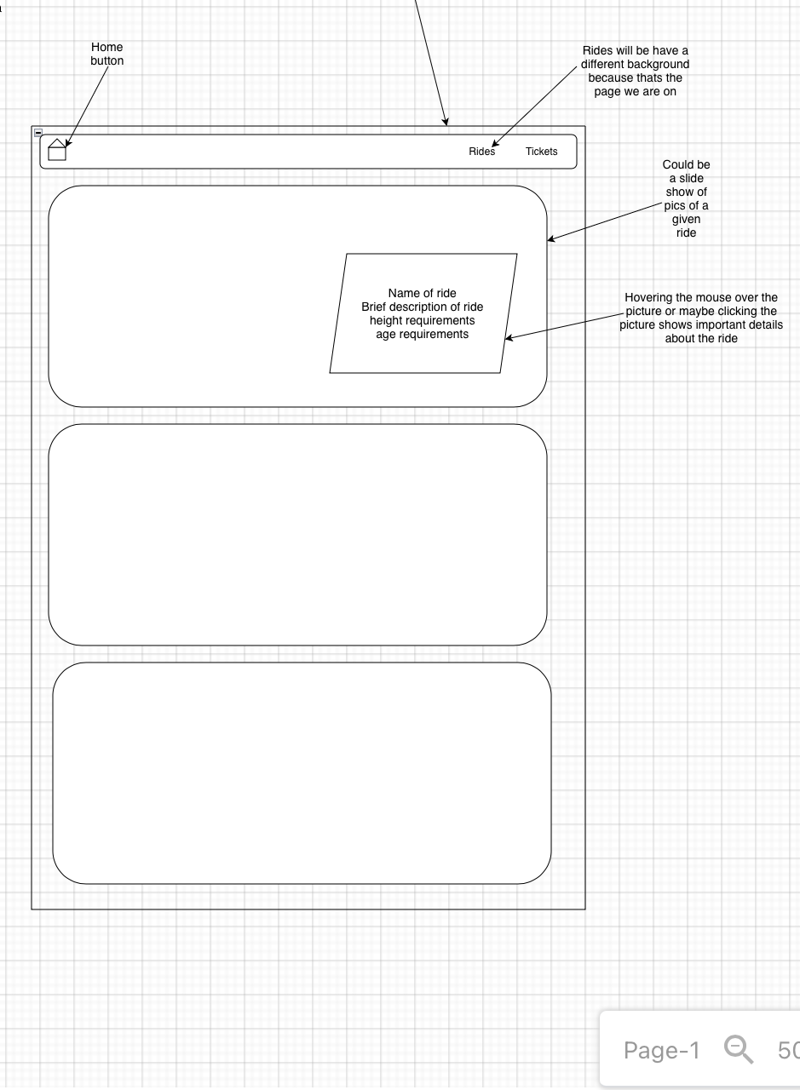

**Draft 1**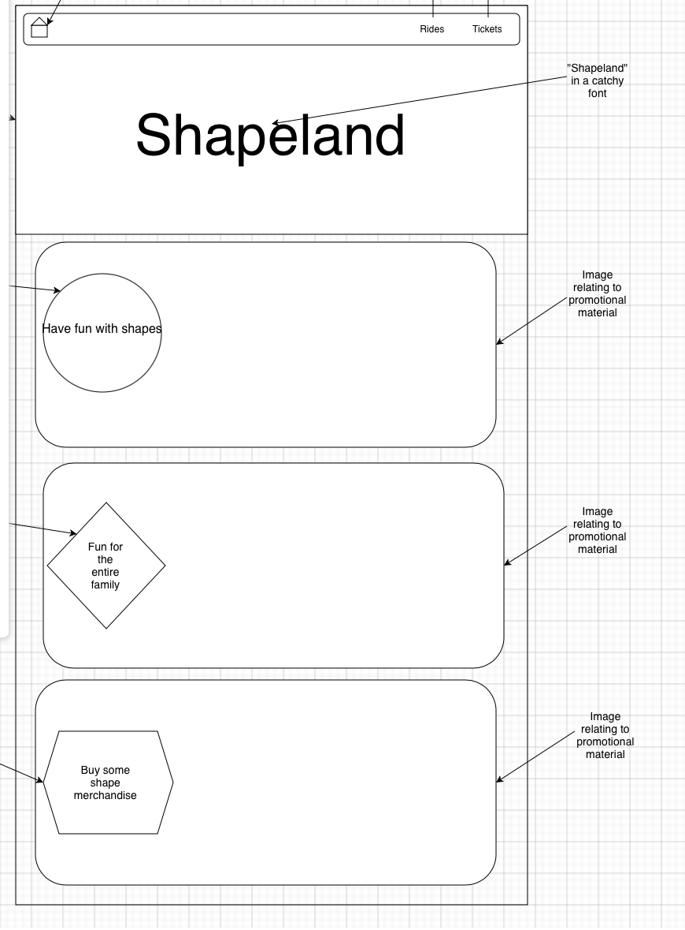

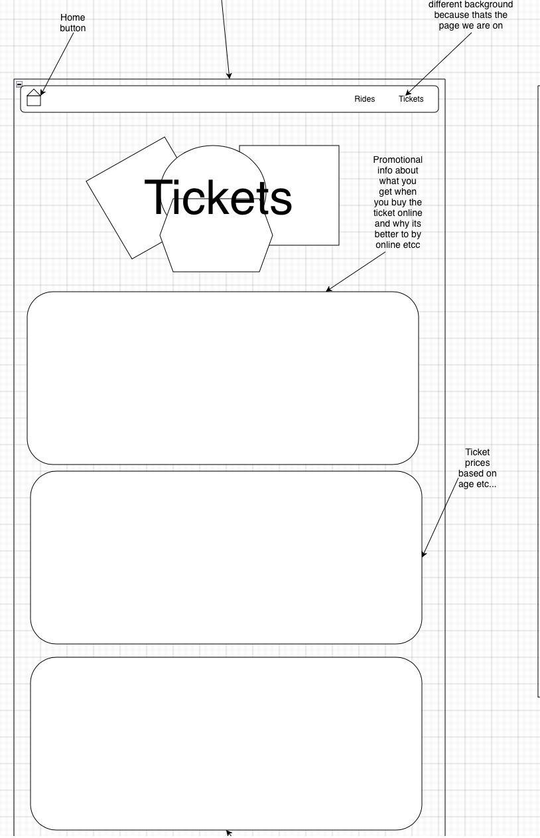

Draft 2

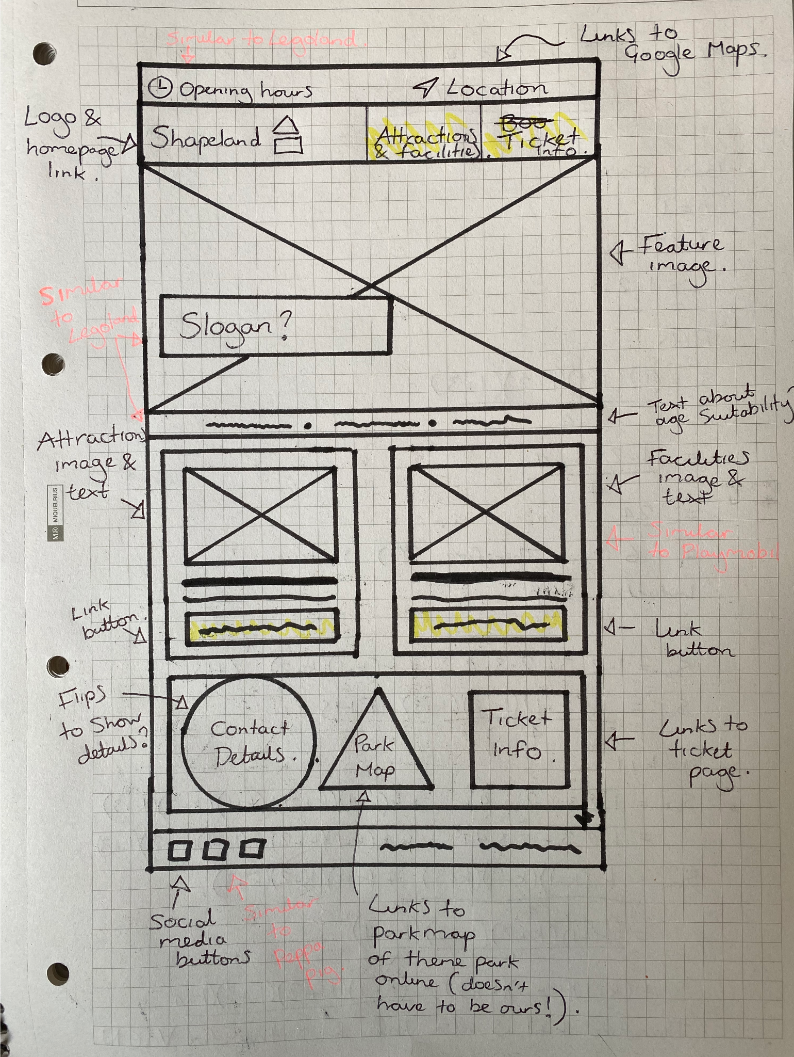

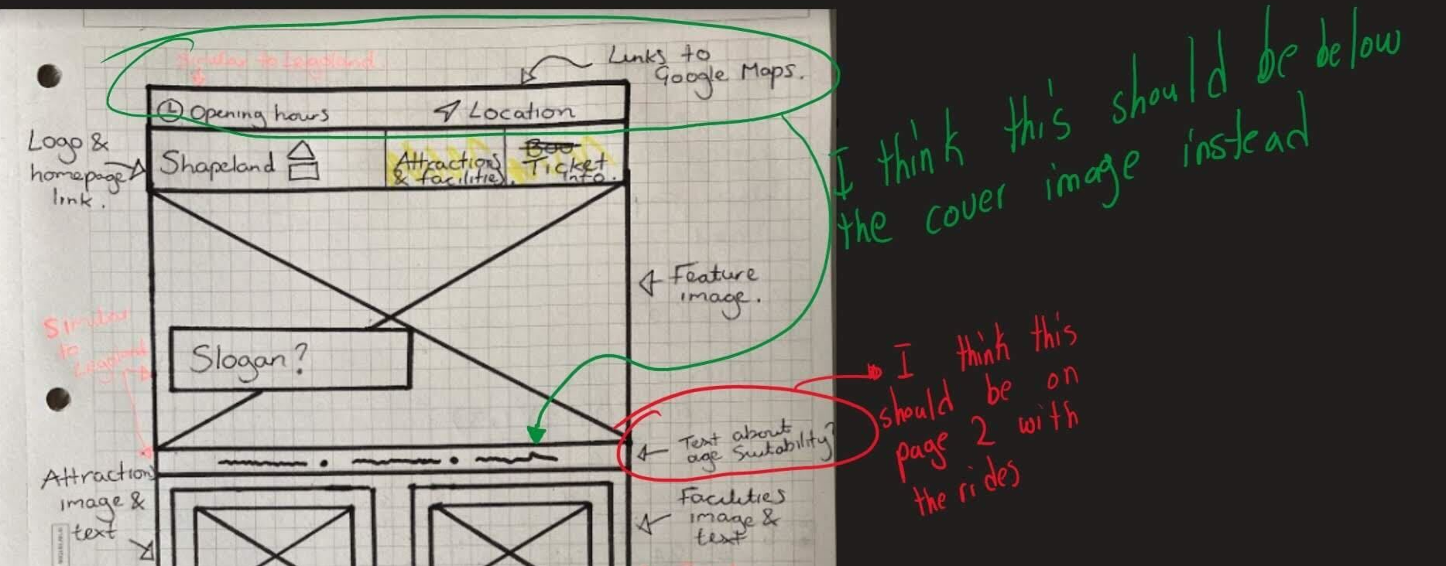

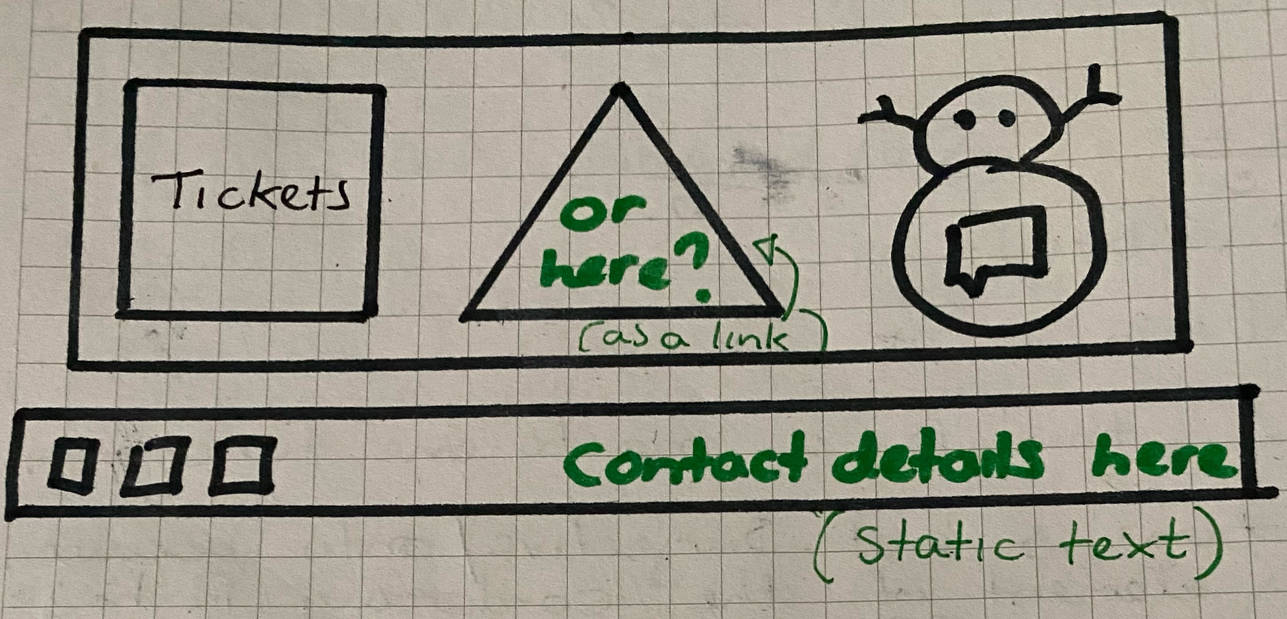

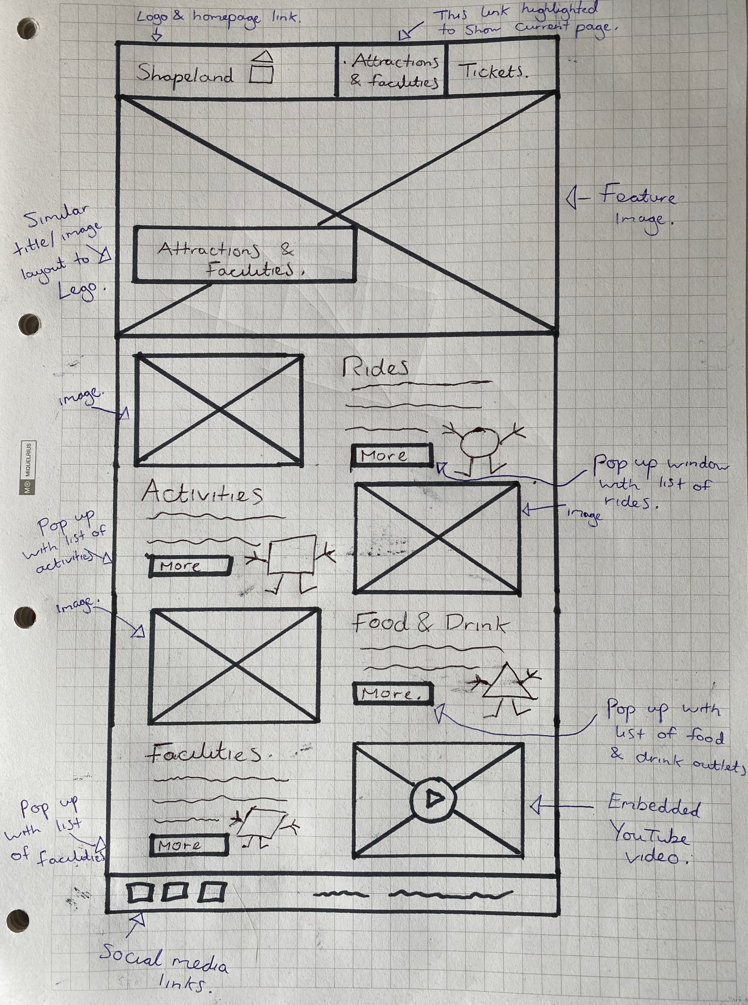

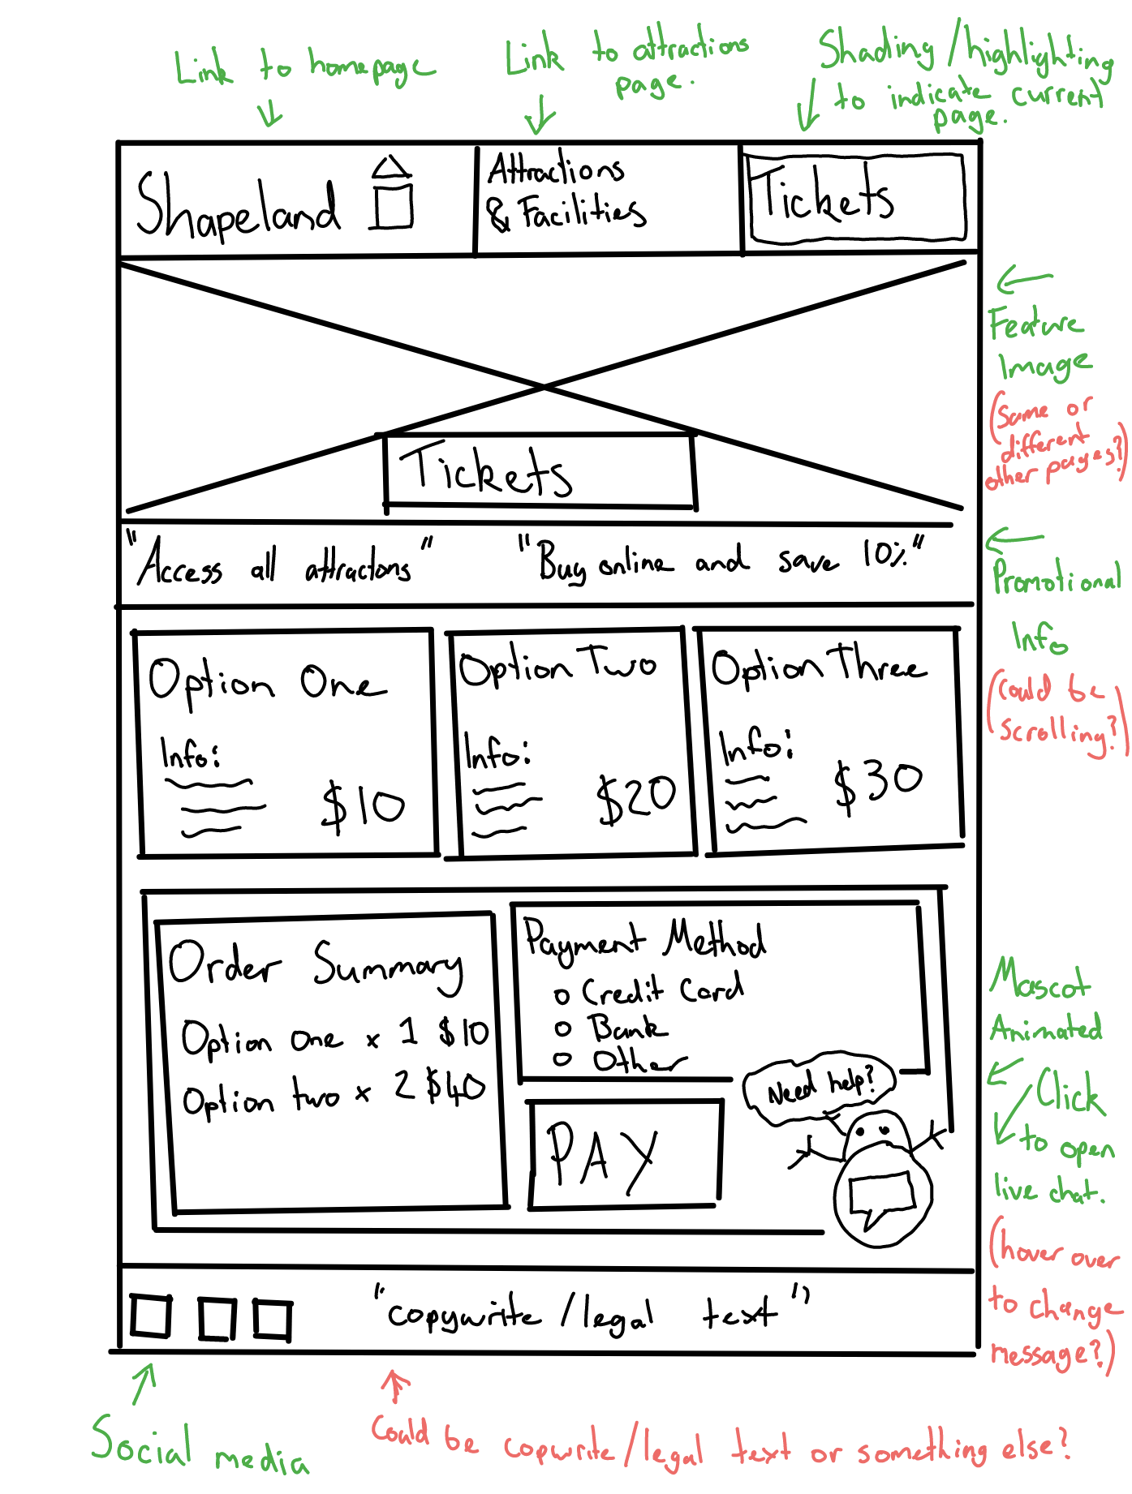

**Final Draft**

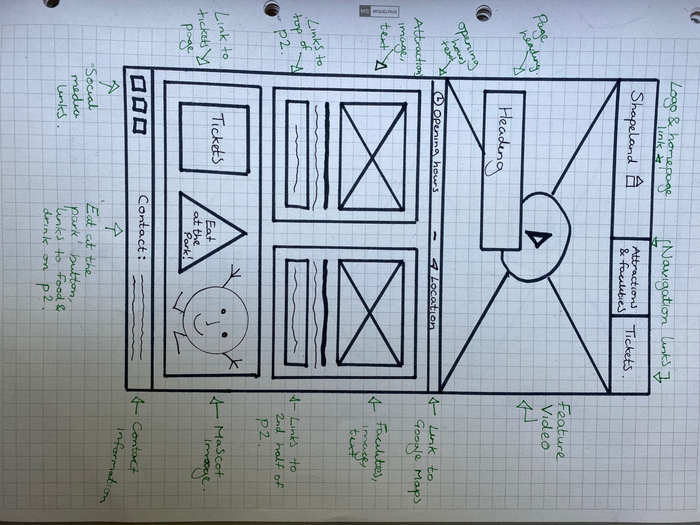

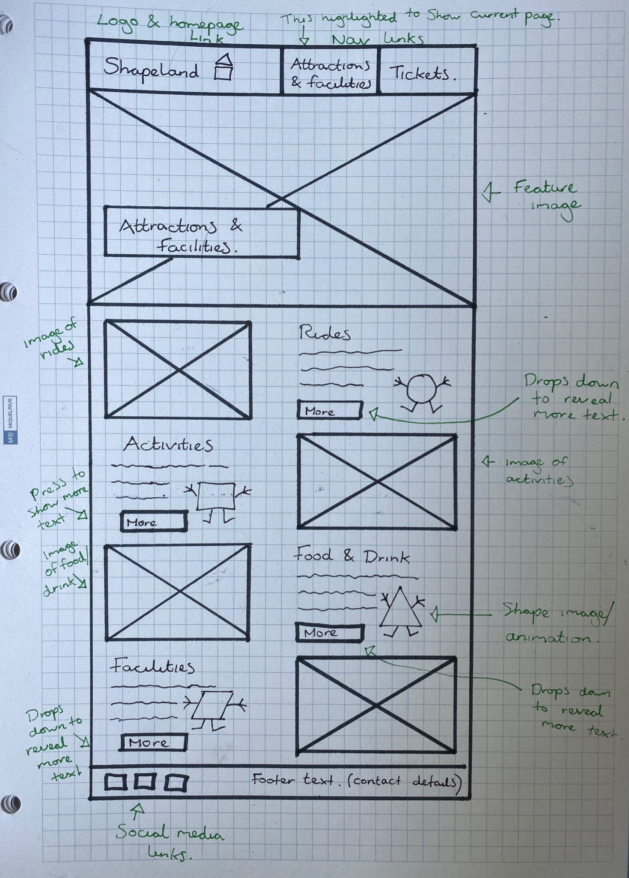

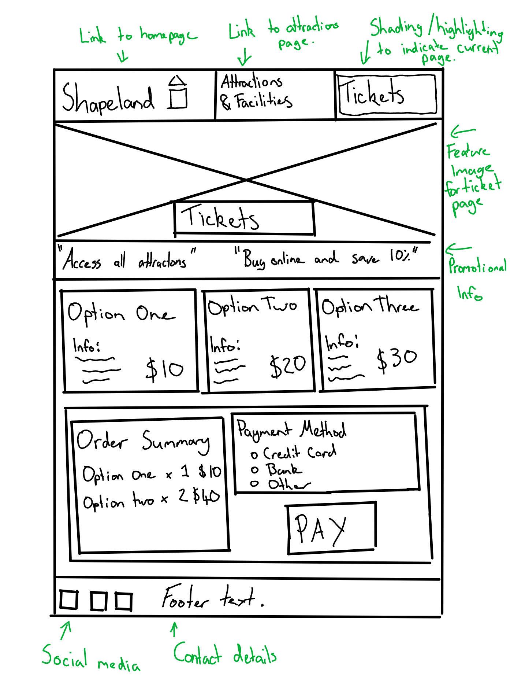

**Small screen**

